|  |  |  |
| --- | --- | --- |
|  | **K. J. Somaiya Institute of Engineering and Information Technology, Sion, Mumbai**  *Accredited with ‘A’ Grade by NAAC (3.21 CGPA)*  *Three Programs* *Accredited by NBA*  *Best College Award by University of Mumbai (Urban Region), ISTE (MH), CSI (Mumbai)* | Description: G:\Kavita\Self Appraisal\trust_logo.jpg |

**DEPARTMENT OF INFORMATION TECHNOLOGY**



***Synopsis of Mini Project On***

PATIENT MANAGEMENT SYSTEM

Prepared By:

Harshit Sonawala (Roll No. 64)

Meet Chudasama (Roll No. 70)

Under the guidance of:

Mr. Prashant Sawant

**Department of Information Technology**

**Academic Year: 2020-2021**

**(REV- 2019 ‘C’ Scheme) - SEM III (SE - IT)**

**K. J. SOMAIYA INSTITUTE OF ENGINEERING & INFORMATION TECHNOLOGY,**

**SOMAIYA AYURVIHAR COMPLEX, EASTERN EXPRESS HIGHWAY, SION, MUMBAI - 400022.**

**K. J. SOMAIYA INSTITUTE OF ENGINEERING & INFORMATION TECHNOLOGY, MUMBAI**

### DEPARTMENT OF INFORMATION TECHNOLOGY

**CERTIFICATE**

## This is to certify that following students:

Roll No. / Seat No.

Harshit Sonawala 64

Meet Chudasama 70

have submitted Mini-Project Report on *“Patient Management System”* as the partial fulfillment for the requirement of Second Year of Engineering (4th Semester) in S.E. - Information Technology under my guidance during the academic year 2020-2021.

|  |  |
| --- | --- |
| **Mr. Prashant Sawant** | **Dr. Radhika Kotecha** |
| **Project Guide** | **Head of Department** |
| **Assistant Professor** | **Associate Professor** |
| **Department of Information Technology** | **Department of Information Technology** |

### 

**Date of Examination: \_\_\_\_\_\_\_\_\_\_\_\_\_\_\_\_\_**

**Signature of Internal Examiner Signature of External Examiner**

**Table of Contents**

|  |  |
| --- | --- |
| Acknowledgement | 4 |
| Abstract | 5 |
| Introduction | 7 |
| Literature Review | 10 |
| Functionalities of Proposed System | 12 |
| Implementation Details and Results | 14 |
| References | 22 |

**Acknowledgement**

We would like to extend our gratitude for our project guide Prof. Prashant Sawant for his excellent guidance and constant support throughout the course of this project.

We would like to thank our mini-project coordinator Prof. Nasim B. Shah, for the invaluable information and help provided by her for the project.

We would also like to thank our Principal Sir, Dr. Suresh Ukarande, our Vice Principal Ma’am, Dr. Sunita Patil, and our Head of Department Dr. Radhika Kotecha, for giving us this opportunity to develop a project, enabling us to gain the knowledge, skills and experience earned in this endeavor.

**Abstract**

The purpose and essence of any records management system is to provide the right information in the right place, in the right order, at the right time for the right person at the lowest cost. This is better achieved by a computer-based system. There are some patient management systems (PMSs) in existence, but they are not readily usable nor are their designs available for improvement. The main objective of this project was, therefore, to design and develop a PMS that would automate patient information management and give direct benefit in certain terms, while avoiding any confusion that would jeopardize the quality of patient care.

The main strategy was, keeping in mind both design and functionality, to develop a desktop application with a major focus on usability and an attractive overall look and feel of a final product. The design and implementation of PMS is presented, a veritable stepping stone.

This Patient Management System allows us to load the specific details of the patient from an excel file and allows us to perform various operations on it. Its functionality at a glance is as follows:

* The user can load the records of the patients by browsing for an excel file. This fills the table with the patient records in the main window.
* After loading the patient records, the user can search for the records based on either the uniquely assigned patient ID, i.e., the PID or the name of the patients and can get the results for the same in a tabular format.
* The user can add the record of an individual patient, specifying all the required details in the new window that opens up.
* They can choose the option to delete all records from the table with a particular patient ID.
* It also allows to clear all values visible in the table in order to load a different data set from an excel file.
* At any point in time, it allows editing of the individual cells from the table in order to make any changes or corrections to the data loaded or manually entered.
* The user can also view the analytics of the amount earned and the amount left to be paid, plotted against the date.
* Finally, after making the desired adjustments to the data such as adding, removing, editing the records, the user can save the records back to an excel file which can be the same file or even a different file.

Providing such a solution with an accessible user interface can be easy to use as well as increase the efficiency of the process of managing the patient details and records.

We have developed this system to be versatile for using in institutions such as hospitals or even small scale clinics and medical facilities. It can act as an effective replacement for centres which cannot afford expensive and complicated solutions which currently exist.

**Chapter 1: Introduction**

Patient Management Systems (PMSs) are comprehensive, integrated information systems designed to manage the information of patients of a medical facility and to be able to view meaningful analytics at a glance as well as easily be able to make changes to the records. Hospitals are becoming more reliant on the capability of patient management information systems to assist in the diagnosis process and management, for better and improved services and practices.

The main goal of PMSs is to streamline the flow of information across the medical institute or clinic towards effective decision making for patient care, in an optimized and efficient manner. Recording of patient information, be it medical, personal, financial or legal, or recording of medical personnel information on paper is at risk of thievery, fire outbreaks, misplacement by employees and even petty things such as handwriting legibility. It is, therefore, vital for a healthcare organization such as a hospital to have an automated patient management information system.

Hospitals are an essential part of our lives and provide us with the best medical facilities. It is necessary for the hospital to keep track of all activities and records day in and day out of its patients, doctors, nurses and other staff that keeps the hospital in its operation.

Keeping track of all activities and reports on paper is very inefficient and time consuming and also error prone. Thus keeping the working of the manual system in mind, we have developed a system called “Patient Management System”. The Patient Management System is designed specially to manage episodes of care quickly and safely.

The aim of the project is to provide a paper-less, low-cost and reliable automation of an unreliable existing system. The intention of this system is to reduce the management effort of the doctors and increase the number of patients that can be treated accurately.

* 1. **Motivation**

We have developed this Patient Management System in order to store the patient records systematically through the use of a graphical user interface which is both easy to use and to incorporate into daily use.

Our proposed system can serve as a powerful solution to the problems of a lack of an automated information storage system or a simpler and robust system with less points of failure. It can act as an effective replacement for centres which cannot afford expensive and complicated solutions which currently exist. It can also be considered as an alternative system when the primary system is unavailable due to some reason like crashes or malfunctions.

Putting our system to use can become a turning point for any medical institution, saving a lot of time and effort and increasing the efficiency of its functioning as well as of providing its services.

* 1. **Objectives**

Our System is designed with the following goals in mind:

* To computerize all details regarding the patients.
* Act as an effective solution for quickly querying the patient information.
* Provide a user friendly interface for managing the patient records.
* To provide accurate analytics based on the patient records at a glance.
* To allow information of the patients to be kept up to date and their past history kept in the system for historical purposes.
  1. **Scope**
* This System will be used in any Hospital, clinics, dispensary, to get information from the patients and then storing the data for future usage.
* The intention of this system is to reduce the management effort of the doctors and increase the number of patients that can be treated accurately.
* We can enhance this system by including more facilities like a pharmacy system for the stock details of medicine in the pharmacy.
* We can further improve the system by adding more validation and error checking for the inputs provided.

**Chapter 2: Literature Review**

* 1. **Related Work**

Bayanno Hospital Management System is one of the many products created by the developers at codecanyon.net. It is a complete multi-language supported management software for hospital, clinic and medical institutes. It supports desktop, laptop, Smartphone and tablet devices. It integrates and facilitates seven types of user area of a hospital, namely Administrator, Patient, Doctor, Nurse, Pharmacist, Laboratorist, and Accountant. The software also includes a security feature which is claimed to be insusceptible to threats such as SQL-injection, XSS attacks and CSRF (Codecanyon.net, 2014). Improvements made by the proposed system regarding Bayanno Hospital Management System include reduced possibility of data redundancy, and cost effectiveness.

Sanjeevani Hospital Information Management System is an integrated health management system, which addresses the critical requirements of hospitals. It is a powerful, flexible and easy to use application designed and developed to convey real conceivable benefits to hospitals and clinics which reduce the paper overload. It streamlines the flow of information across the hospital that helps effective decision making for patient care, hospital administration/management and streamline financial accounting in an optimized and efficient manner. Out- and In-patient Management, Emergency Patient Management, and Laboratory Tests, among others (Centre for Development and Advancement of Computing, 2014). The proposed system adopts this systems’ ideology of emergency patient management.

OrangeHRM offers a flexible and easy to use Human Resource Information System (HRIS) solution for small and medium sized companies free of charge. By providing modules for personnel information management, employee self-service, leave, time and attendance, benefits and recruitment companies are able to manage the crucial organization asset - people. The combination of these modules into one application assures the perfect platform for re-engineering and aligning HR processes along with organizational goals (OrangeHRM, 2013).

Most existing healthcare management systems are too generalized. This may result in omission/abstraction of necessary information which can result in horrendous consequences.

* 1. **Existing System**

Currently, there exists an immense number of medical establishments ranging from small clinics to globally renowned hospitals, some of which use automated databases, but all institutions require an effective system in place for the purpose of storing the information of patients.

For small scale establishments, there may be some places where this process is done manually as either the commercially available solutions are too expensive, too complicated or just not feasible. For such use cases, our system represents the perfect solution, providing for a simple yet efficient system to add, remove, edit and manage the patient records and is coupled with a very accessible user interface.

For larger scale establishments using advanced management solutions, our system can be a better alternative due to less complexity and therefore less training required for employees to use it on a day to day basis.

It can also act as a backup system when the primary system is unavailable due to failure or some other reason.

**Chapter 3: Functionalities of Proposed System**

Our proposed system of a Patient Management System provides the essential functionalities of loading records from an excel file, adding and removing patient records, editing existing records, searching patient details, as well as providing analytics for the data, saving the records to an excel file, and refreshing and clearing the records for loading a different dataset.

* Loading Records:

The user can press the “Open File” button which opens up a window which prompts them to browse for the excel file from which to initially load the records into the table in the main window.

* Searching Patient Details:

The “Search” button can be pressed to open up the search window where the user can search for the patient details based on the PID or the name of the patient.

* Add Record:

The “Add Record” button, when pressed opens up the window where the user can add a record of a patient by filling in the patient details. The user enters the desired patient details and presses the “Add” button to add it to the database.

* Deleting Records:

The “Delete Record” button opens up the window where the user can enter the PID of the patient whose information they want to delete. Then they can press the “Delete” button in order to delete the record from the database.

* Refresh Records:

The “Refresh” button’s main function is to update the values in the table on the main window after a record has been added or deleted. It can also be used at any time to reload the records which were in the database prior to an edit made in the table.

* Clear Records:

The “Clear” button clears the table on the main window of any records so that the records can be loaded from a different excel file or from the same file again.

* Save Edits:

At any point, the cells in the table on the main window can be edited to change the values of any patient record and then the “Save Edits” button can be pressed to save these changes made into the database in order to update the analytics with the latest information.

* Get Analytics:

The “Get Analytics” button opens up a window which displays the graph plot of the amount of earnings and the amount pending to be paid with respect to the date. Furthermore, the main window provides the total earnings and total pending amount.

* Saving Records:

After making the desired changes to the patient database like adding, removing, editing etc. the “Save File” button can be pressed to save the records back into an excel file. A window opens up where the user can browse for where and with what name they want to save the excel file.

**Chapter 4: Implementation Details and Results**

**Hardware Requirements:**

Processor : Any Dual Core Processor or better

RAM : 2GB or more

Hard disk : 80GB or more

Monitor : LCD Monitor

Keyboard & Mouse :Any compatible mouse & keyboard

**Software Requirements:**

Python : Version 3.6 or Higher

For Backend : SQLite3, pandas

GUI : PyQt5

Graphs : Matplotlib, Numpy

**Implementation:**

For Frontend (GUI): The Qt Designer tool is used which provides a drag and drop interface for designing the windows and pages of the application.

A total of 5 windows and 1 dialog are created and designed using the Qt Designer.

Each window has a different arrangement of UI elements which are the QtWidgets such as QLabels, QPushButtons, QLineEdits, QComboBoxes, QTableWidgets, etc.

The styling is added to the base UI by providing the CSS for each of these QtWidgets elements. Styling is applied to these elements such as specifying the font, borders, colours, change colour on hover, etc.

On the Main Window, there are 9 buttons, each of which is connected to its function defined in the Ui\_MainWindow() class.

Functions used are:

1. openFile(): Opens a QFileDialog to browse for the excel file. It then calls loadRecords().
2. loadRecords(): pandas is used to read the data from excel file, store it in a dataframe and then store it into the SQLite3 database as well as display it on the QTableWidget on the main page. It calls loadTotals() to update the analytics.
3. saveFile(): Opens a QFileDialog to browse for the excel file. It then calls saveRecords().
4. saveRecords(): Table data is read and stored into a pandas dataframe and then that data is written to the excel file.
5. searchRecord(): Opens the search window where the sql query is run based on the input to search for the records.
6. loadTotals(): Runs the SQLite3 query to calculate the total amount earned and pending.
7. addRecord(): Opens the add window which allows for input and insertion of record into the database.
8. deleteRecord(): Opens the delete window which allows for input of the PID to delete the records of that patient.
9. refreshTable(): Used to update the QTableWidget on the Main Window and then calls loadTotals() to update the analytics.
10. clearTable(): Empties the QTableWidget on the Main Window in order to load a different set of records from a file.
11. saveEdits(): After any changes are made to the QTableWidget, a press of this button commits those changes to the database. It calls saveRecords() as well as loadRecords() and then loadTotals().
12. getAnalytics(): Used to open the window where the graph of the amount earned and amount pending are plotted against the date using matplotlib.

**Output Screenshots:**

Main Window: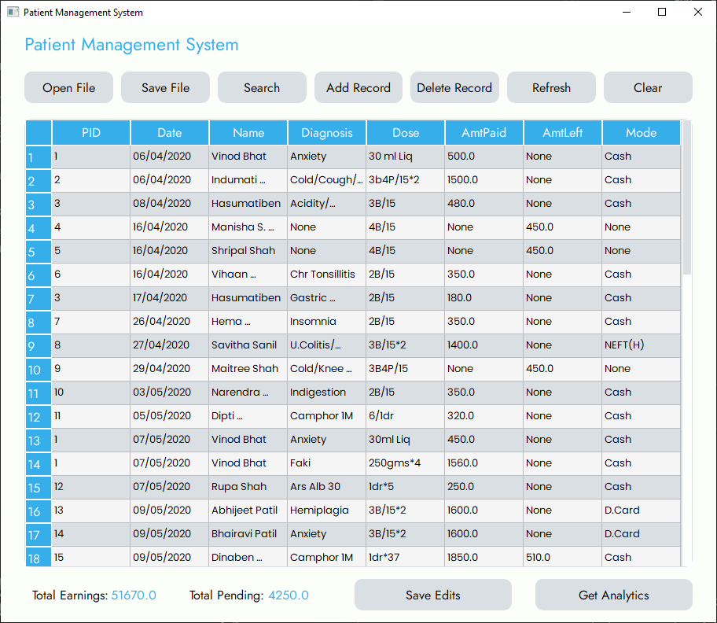

Search Window: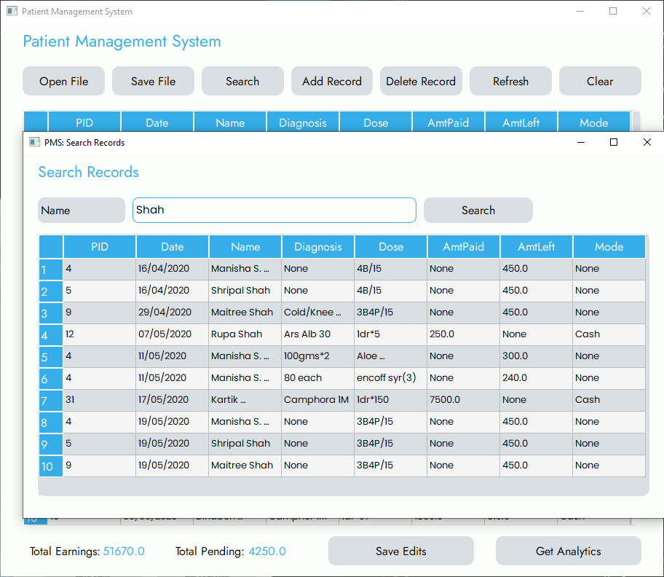

Add Window: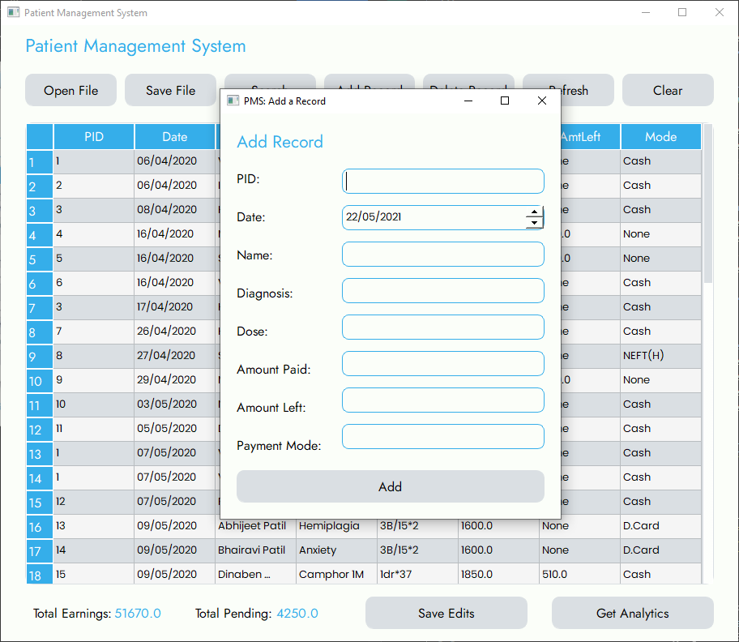

Delete Window: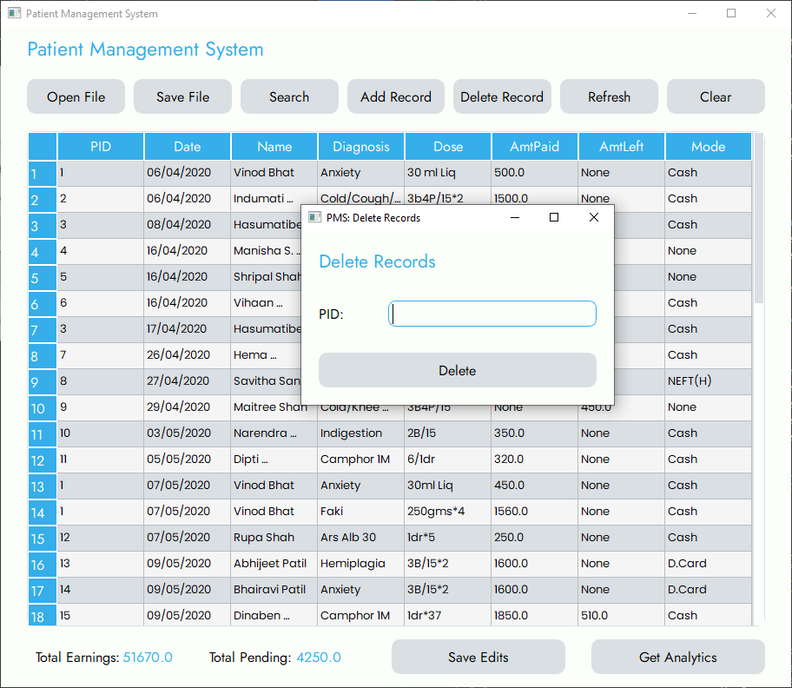

Analytics: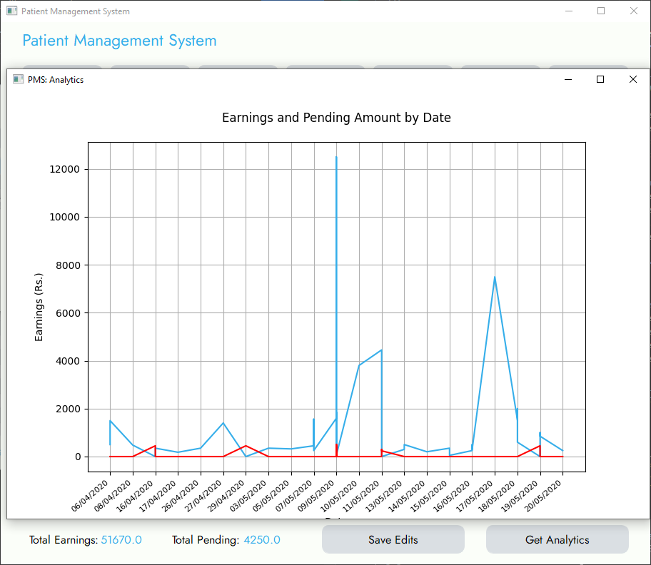

Data Saved in Excel Sheet on Saving File: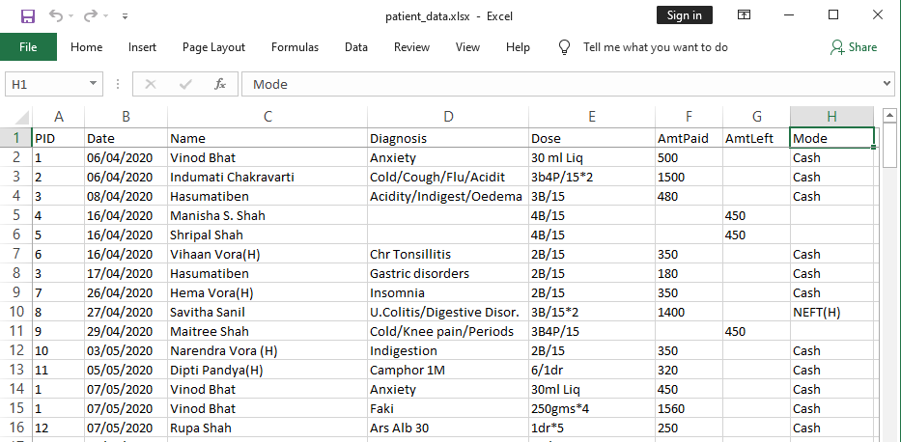

**Chapter 5: References**

1. For Record of Systems. Retrieved from

<http://www.slideshare.net/dorisacheng/hospital-records-management-system>

1. For Making of Synopsis. Retrieved from

<https://publication.babcock.edu.ng/asset/docs/publications/COSC/9457/1887.pdf>

1. For Preview of Project. Retrieved from

<https://www.slideshare.net/Yawamofah/patient-management-system-project>

1. Python and PyQt5 related Information. Retrieved from

<https://www.w3schools.com/python/>

<https://www.mfitzp.com/tutorials/basic-widgets/>

1. Database related information. Retrieved from

<https://www.sqlitetutorial.net/sqlite-python/>